Exp No : 5 Date : 21-03-2019
SHELL PROGRAMMING - 1

Aim :
To practice various shell scripting programs

Programs :

Ouestion 1 :-
Write a shell script to show various system configuration like
1. Currently logged user and his login name
2. Your current shell
3. Your home directory
4. Your operating system type
5. Your current path setting
6. Your current working directory
7. Number of users currently logged in

Program :
echo "Corrently logged user is '$USER' and login name is '$LOGNAME'"
echo "Current shell : " $SHELL
echo "Home directory : " $HOME
echo "Operating System type : " $OSTYPE
echo "Current path : " $PATH
echo "Current working directory :" $PWD
echo -e "Currently logged `who --count | sed -n 2p | cut -b 3-` "

Output :
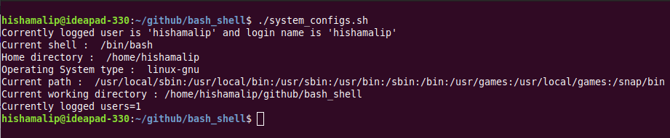
------------------------------------------------------------------------------------------------------------------------

Question 2 :-
Write a shell script to show various system configurations like
1. your OS and version, release number, kernel version
2. all available shells
3. computer CPU information like processor type, speed etc
4. memory information
5. hard disk information like size of hard-disk, cache memory, model etc
6. File system (Mounted)

Program :
echo "1. OS and version, release number, kernel version"
cat /etc/os-release | head -2
echo "Kernal version : `uname -r`"
echo -e "\n2. All available shells"
cat /etc/shells
echo -e "\n3. Computer CPU information like processor type, speed etc."
lscpu | head -20
echo -e "\n4. Memory informations"
cat /proc/meminfo | head -15
echo -e "\n5. Hard disk information"
sudo lshw -c disk
echo -e "\n6. File system (Mounted)"
lsblk /dev/sda

Output :

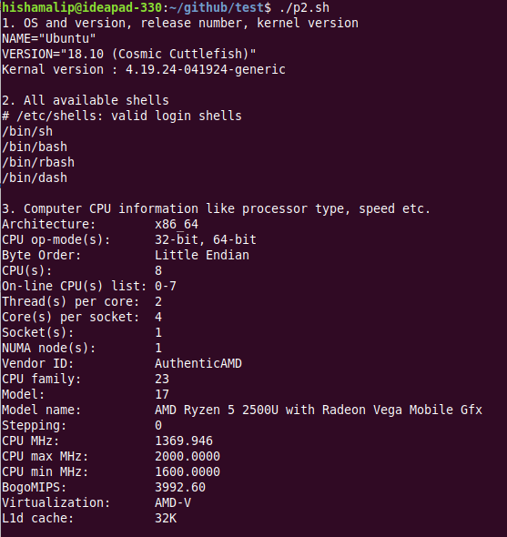



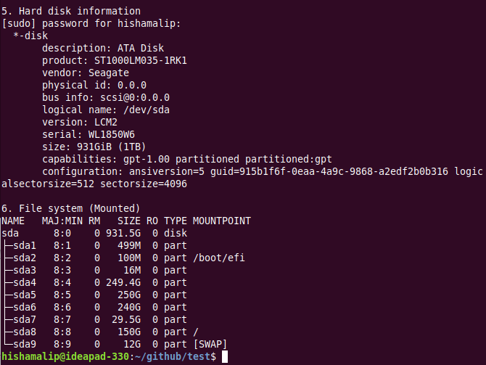

Question 3 :-
Write a shell script to implement a menu driven calculator with following functions
1. Addition
2. Subtraction
3. Multiplication
4. Division
5. Modulus

Program :
function input() #function to read two numbers
{
read -p "Enter first number : " num1
read -p "Enter second number : " num2
}
function prompt() #function to prompt a message
{
echo "Do you want to continue"
read -p "Yes or No - y/n : " flag
if [ $flag = "n" ] ; then
echo -e "Program Exited\n"
exit
elif [ $flag != "y" ] ; then
echo "Invalid input"
prompt
fi
}
function addition() #function for addition
{
echo "-----Addition-----"
input
result=`expr $num1 + $num2`
echo -e "Sum is $result \n"
}
function subtraction() #function for subtraction
{
echo "-----Subtraction-----"
input
result=$(expr $num1 - $num2)
echo -e "Difference is $result \n"
}
function multiplication() #function for multiplication
{
echo "-----Multiplication-----"
input
result=`expr $num1 \* $num2`
echo -e "Product is $result \n"
}
function division() #function for division
{
echo "-----Division-----"
input
result=$(expr $num1 / $num2)
if [ $num2 -eq 0 ]; then
echo -e "Can't define. \n"
else
echo -e "Quotient is $result \n"
fi
}
function modulus() #function for modulus
{
echo "-----Modulus-----"
input
result=`expr $num1 % $num2`
echo -e "Modulus is $result \n "
}
echo "--------------------"
echo " CALCULATOR"
echo "--------------------"
while true ; do
echo -e "1.Addition\n2.Subtraction\n3.Multiplication\n4.Division\n5.Modulus\n"
read -p "Select your choice : " ch
case $ch in
1) addition;;
2) subtraction;;
3) multiplication;;
4) division;;
5) modulus;;
*) echo "Invalide Choice";; #default case
esac
prompt
done

Output :
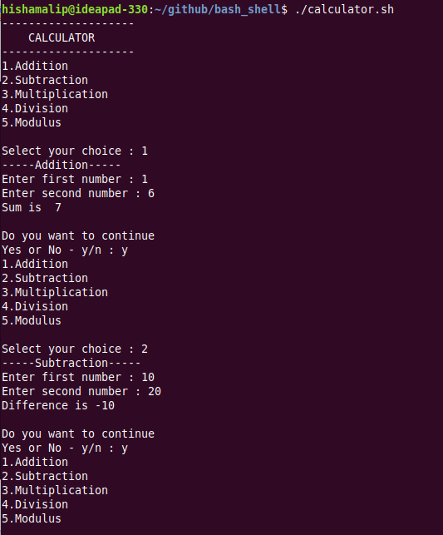

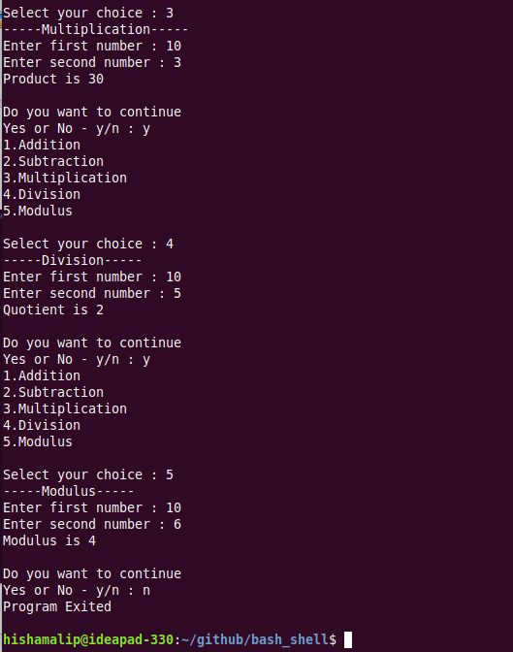

Question 4 :-
Write a script called addnames that is to be called as follows ./addnames ulist username. Here ulist is the name of the file that contains list of user names and username is a particular student’s username. The script should
1. check that the correct number of arguments was received and print a message, in case the number of arguments is incorrect
2. check whether the ulist file exists and print an error message if it does not
3. check whether the username already exists in the file. If the username exists, print a message stating that the name already exists. Otherwise, add the username to the end of the list.

Program :
if [ $# -ne 2 ] ; then
echo "Invalide number of arguments"
exit
else
file1=$1
if [ ! -f $file1 ] ; then
echo "File $1 not exist"
elif [ -f $file1 ]&&[ $file1 != "ulist" ] ; then
echo "The file "\"$file1"\" cant be used for this operation"
else
uname=$2
uname_check="$(cat ulist|grep -w $uname)"
if [ "$uname_check" == "$uname" ] ; then
echo "Username already exists"
else
echo $uname >> $file1
echo "$uname is added to $file1"
fi
fi
fi

Output:
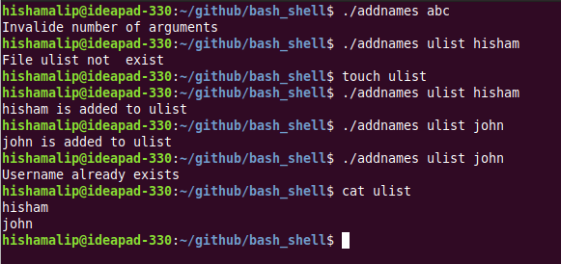
Question 5 :-
Write a Shell script which starts on system boot up and kills every process which uses more than a specified amount of memory or CPU.

Program :
ps -e -o pmem=,pcpu=,pid=,comm= | sort -r -k 1 | while read memsize cpusize pid command ; do
xcpu=1
xmemory=1
check="$(echo "$cpusize>$xcpu" | bc || echo "$memsize>$xmemory" | bc)"
if [ $check -eq 1 ] ; then
echo -e "PID:$pid CPU:$cpusize Memory:$memsize - $command-is killed"
kill $pid
fi
done

Output :

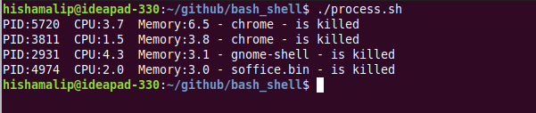

Result :
Practiced various shell scripting programs and output is verified.

